**An epic** is a large user story which is too big to fit into a sprint.

**Scrum is a framework** that helps agile teams to work together. Using it, the team members can deliver and sustain the complex product. It encourages the team to learn through practice, self-organize while working on the problem. Scum is a work done through the framework and continuously shipping values to customers.

**Scrum Master:**

The Scrum Master is not a management title and cannot make decisions on behalf of the team. The Scrum Master's major responsibility is to ensure that scrum is understood and practiced by every team member in the true spirit.

The Scrum Master should understand the different skill sets of his or her team and group them by having the right sheep in the right flock. A Scrum Master should guide the team such that the team does not go astray and fall prey to excess time and energy.

Just like a shepherd, a Scrum Master must draw out quiet people during stand-up meetings or when planning poker sessions. Whenever the team loses focus or a team member goes astray, the Scrum Master aka the shepherd should bring the lost one back to the flock and guide appropriately.

The Scrum Master should not enforce agile practices on the team, but should do a 'Servant leadership' role. Scrum Master should lead by example and be a living demonstration of team assets and scrum values.

He or she should create an environment of safety for the team, and guide and facilitate team collaboration. He or she should refrain from solving problems or making decisions by guiding teams to do so.

To summarize, a Scrum Master:

* **Is a servant leader -**mentors and coaches the teams on scrum theory and practices, guides them on how they need to adapt to those, thereby realizing the benefits of scrum both at team level and organization level.
* **Helps remove obstacles/impediments -**supports the Development teams in removing the impediments by reaching out to the right people, thereby ensuring a smooth development progress without disrupting the team.
* **Facilitates collaboration -**enables interactions within the team as well as between the team and the Product Owner.
* **Teaches scrum -**to the team.
* **Protects the teams -**from external disruptions such as changes to stories in the current sprint.
* **Is a change agent -**in growing the organization to deliver early and often, and removing waste

# **Scrum Meeting**

## What Is a Scrum Meeting?

Scrum is an [agile](https://www.productplan.com/agile-product-management/) framework that teams use to produce products faster by breaking large development projects into smaller pieces that can be completed in short timeframes. Scrum meeting is a catch-all term that can describe different types of meetings held by Scrum teams. Scrum meetings include daily standups, sprint planning sessions, and sprint retrospectives.

## Who Attends a Scrum Meeting?

Most Scrum meetings, including the ones we will discuss below, should include the entire Scrum team. For most companies, the team includes the following roles:

* [**Scrum master**](https://www.productplan.com/glossary/scrum-master/)(the team’s facilitator and point person)
* [**Product owner**](https://www.productplan.com/glossary/product-owner/) (the project management lead for the agile team)
* **Development team**

## What are the Different Types of Scrum Meetings?

A Scrum meeting can refer to any meeting held by a Scrum agile team during a product’s development. Here are the most common types.

### **Daily Scrum**

The daily scrum, also called the standup, is a short daily meeting designed to let the team plan out its work for the day and identify any obstacles that could impact that work.

Most teams hold these meetings in the morning and limit them to 10 or 15 minutes. They are sometimes called standups because many teams hold them standing up to keep them short and focused.

### **Sprint Planning**

It is a team meeting held before the next agile sprint. The team reviews its backlog during sprint planning and decides what items to [prioritize](https://www.productplan.com/product-management-frameworks/) for the next sprint.

The team will have two items by the end of a sprint planning meeting. The first is a sprint goal (a summary of the plan for the next sprint). The second item is the [sprint backlog](https://www.productplan.com/glossary/sprint-backlog/) (the list of projects the team will work on during the sprint).

### **Sprint Retrospective**

It is a post-sprint discussion. The Scrum team reviews what happened during the sprint to determine what worked, what didn’t work, and how they can improve the process during the next sprint.

A sprint retrospective is a narrower and more frequent version of the product [retrospective](https://www.productplan.com/glossary/retrospective/): a meeting held after the launch of a product to assess what worked and what needs improvement.

**What are sprints?**

With scrum, a product is built in a series of repetition called **sprints**. It breaks down big complex projects into bite-size pieces. It makes projects more manageable, allows teams to ship high quality, work faster, and more frequently. The sprints give them more flexibility to adapt to the changes.

.

Sprints are a short, time-boxed period for Scrum team that works to complete a set amount of work. Sprints are the core component of Scrum and agile methodology. The right sprints will help our agile team to ship better software.

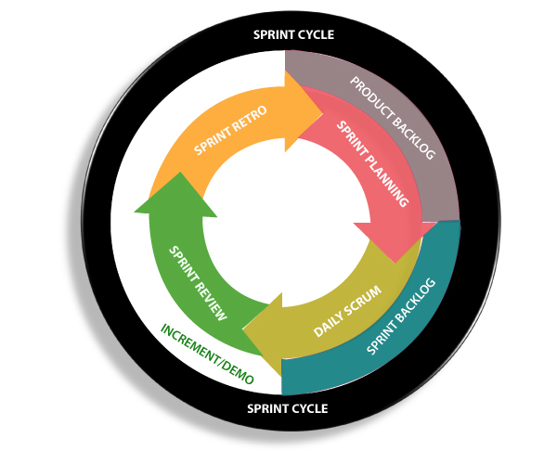

**What is sprint plan?**

Sprint plan is an action in Scrum that kicks off the sprint. The primary purpose of sprint plan is to define what can deliver in the sprint. It also focuses on how the work will be achieved. It is done in combination with the whole Scrum team members.

The sprint is a set of the period where all the work to be done. Before we start the development, we have to set up the sprint. We need to describe how long time is required to achieve the sprint goal and where we are going to start.

Factors affecting Sprint planning

* **The What:** The product owner describes the goal of the sprint and the backlog items which contribute to achieve that goal.
* **The How:** Agile development team plans its necessary work on how to achieve and deliver the sprint goal.
* **The Who:** The product owner defines the goal based on the value that the customers seek. And the developer needs to understand how they can or cannot deliver that goal.
* **The Inputs:** The product backlog provides the list of input stuff that could potentially be part of the current sprint. The team looks over the existing work done in incremental ways.
* **The Outputs:** The critical outcome of sprint planning is to meet described team goal. The product set the goal of sprint and how they will start working towards the goa